

Southern Maine Sea Kayaking Network

GUIDELINES FOR TRIP ORGANIZERS

April 2023

Due to Meetup features, only individuals designated as Meetup “Event Organizers” can post trips on the SMSKN Meetup home page. Event Organizer status is open to all SMSKN members and is conferred to individuals who request it by the President. For the safety of our members and protection of our Club, we ask that Event Organizers comply with the following guidelines when posting and conducting trips.

1. Post a clear and accurate description of the trip and required equipment on Meetup description. This is important so that people don’t sign up for trips for which they are not prepared or equipped. Specify trip length (in NM) and duration, any known hazards, and gear and clothing requirements (drysuits, helmets). A pdf and sprayskirt are required on all our trips and specifying boat type (usually 16 ft+ decked sea kayak with watertight compartments and static deck lines) is recommended. Trip levels are shown below and are useful but not required.
2. Track the marine weather for the day of your trip. Attendees may not check marine weather, so you should keep a careful eye on it. Be cautious about definitively describing weather in the announcement, since conditions can change significantly over a few days. Rather, you can provide the current forecast and recommend that they check the NOAA site before departure. If conditions worsen and trip level changes, amend the writeup and if necessary notify attendees, which can be done through the “Manage” button on your Event page.
3. Check the Meetup page regularly before the trip and respond to communications from participants. Your Meetup settings should be set to allow direction communications; see smskn.net/Resources/Meetup Comms Settings to check yours.
4. Be specific about departure time. Traditionally, the trip start time is the launch (“butts in boats” or “paddles wet”) time for SMSKN trips—please be specific about this in your posting.
5. Make sure everyone has signed the online Participant Agreement and have some hard copies for those who haven’t. Our Membership Manager normally checks this beforehand and will let you know if anyone has not signed, but sometimes guests show up. Hang onto hard copies and give them to club leadership, either in hard copy or electronically.
6. Hold a launch meeting before setting out. This is important, since the information provided will help attendees determine whether the trip is or is not within their abilities. Please do the following, at a minimum:
   * Discuss the planned route, including length and duration, with the group and make sure everyone either has a chart or is clear about directions.
   * Check to be sure everyone is properly equipped.
   * Describe the latest marine weather forecast and tides, noting specifically predicted winds and wave heights.
   * Find out who has radios and confirm the group channel.
   * Discuss any safety concerns and potentially challenging conditions. Ask politely if anyone has a medical concern (recent shoulder trouble, etc.) to share with the group or with you privately.
   * Ask that the group stay reasonably close together, particularly in areas of boat traffic. Ask participants to notify you if they want to split off from the group.
   * Remind everyone that they are responsible for their own safety, but that communication is important. Encourage them to communicate anything of concern at any point to anyone in the group (e.g., “hey Bill, I noticed your stern hatch cover isn’t completely on—can I help you with that?”)

As the Event Organizer who posted the trip, be aware that you have the right to deny anyone whose gear, boat, skills or other characteristics are in your opinion unsuitable for the trip. This is necessary to keep everyone safe.

Once underway, keep an eye on the group during the trip, and make sure you come back with everyone you left with, unless arrangements were made otherwise. But most importantly:

Have fun!

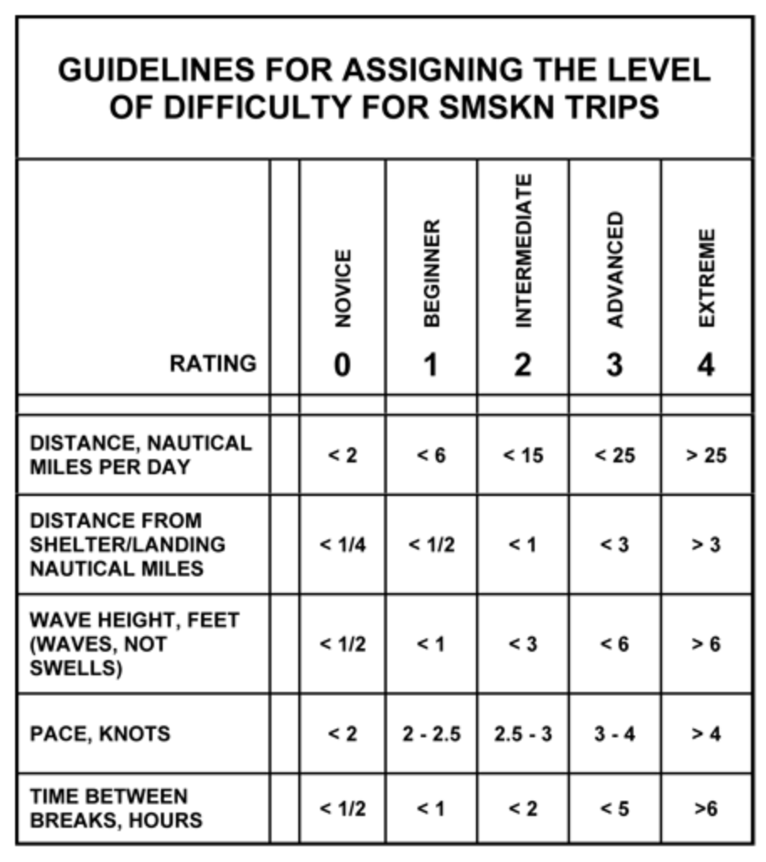

Consider wind as well. All criteria are approximate and are intended for general categorization only.